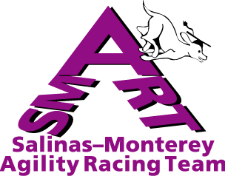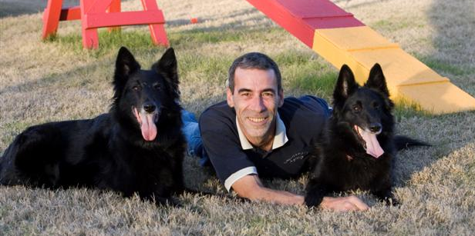
Guy Blancke Agility Handling Seminars

Workin’ Paws, 690 Tevis Trail, Hollister

Handling Foundation – Sat Sept. 8 (8am-5pm)
Advanced Handling – Sun Sept. 9 (8am-5pm)

Stressing maintaining a connection with your dog and running with your dog laterally rather than ahead or behind, Guy Blancke’s agility handling seminars offer handlers a way to analyze and run agility courses with outstanding smoothness and efficiency. Guy uses video technology to analyze each handler’s skills, teach handlers how to find the best lines, and provide valuable individualized coaching that allows handlers to understand every detail of their runs and thus make the right adjustments toward better performance.

Guy Blancke, and his Belgian Shepherd Unia have garnered top international agility honors including winning the 1999 Agility-Welt Cup, 1999 FCI Agility World Cup (vice-champions), and the 2000 Belgian National Championship. Guy coached and competed with the CKC Canadian team at the 2003 World Championships and has coached and given seminars in agility for over 20 years.

SMART is offering two one-day seminars:

• a Handling Foundation seminar (Saturday) for people who have not previously attended a Guy Blancke seminar; no contact equipment or weave poles will be used since the emphasis will be on communicating with your dog on course and finding the smoothest and most efficient paths between obstacles; young dogs preparing for competition are especially welcome as long as they have plenty of jumping experience.

• an Advanced Handling seminar (Sunday) for people who have previously attended a Blancke seminar. We will give previous Blancke attendees priority for the working spots in this seminar, but Handling Foundation participants may audit the Advanced seminar at the reduced price of $48 if not enough working spots are available to meet the demand.

The seminar fee for each one-day seminar is $120 for a working spot and $60 to audit (Smart Members $96/$48 as the standard club 20% discount). Fee includes morning and afternoon munchies and drinks but BYO lunch. For Questions, contact Derede Arthur, 831-757-7467 or dlarthur@ucsc.edu.
__________________________________________________________________________________
To register, send BY AUGUST 17 the form below and checks made out to SMART to Derede Arthur, SMART Blancke Seminar, 1266 Old Stage Rd. Salinas, CA 93908( Confirmations by email only)

Name:_____________________________________________SMART member?__ (please adjust prices if so)___
Full address:_______________________________________________________________________________
Phone:____________________________________Email___________________________________________
Indicate fee enclosed: Handling Foundation (Sat): working ($120)__________audit($60)___________________
Advanced Handling (Sun): working( $120)__________audit($60)___________________
Type of dog and competition level_______________________________________________________________

