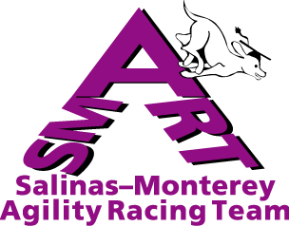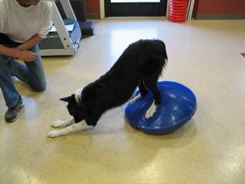

Conditioning and Fitness for You and Your Dog
Workin’ Paws Agility Facility, Hollister
Sunday May 21, 9 am – 5 pm

The Salinas-Monterey Agility Racing Team (SMART) is proud to offer a canine and human conditioning seminar with Sarah Johnson, M.A. Demo dogs will demonstrate the exercises, and you use your dog to learn how to stretch and warm up. The seminar will cover:

- Ready – Steady –Go: How to warm up dog and handler
- The “A B C’s” For a Fast Dog Agilty Handler: how to improve your Agility, Balance, Coordination and Speed on course without getting injured. Be ready for a workout: bring your running shoes!
- How to be in “SHAPE” to be injury free; how to prevent and care for handler injuries
- Passive stretching: dog & handler
- Active stretching: dog & handler
- The importance of having a fit and well balanced dog
- Conditioning for healthy dogs – body awareness: core strengthening, muscle strength & endurance, proprioception and balance training, cross training, common sense training

• Step by step instructions of “Sarah’s Box & ” CordDisc exercises for dogs

• Lifting and moving agility equipment safely

• Lots of Handouts!

Sarah received her master’s degree in Exercise Physiology in 1985 and has worked in a variety of health specialties from cardiac and diabetes rehabilitation to health clubs, spas, and a Pilates studio; for eight years, she utilized Pilates for rehabilitation in a medical office specializing in overcoming chronic pain. She has completed the Canine Rehabilitation program at University of Tennessee Veterinarian College and now works at The Andrew Sams Clinic in Mill Valley developing and implementing a canine rehabilitation program. Sarah has competed in agility for 7 years with her border collies ADCH Rav and MACH, Silver ADCH Cruiser; she can be reached at sarah@fitdogs.net.

This seminar will run from 9 am sharp to 5 pm at Workin’ Paws in Hollister. SMART will provide water , sodas, and coffee for all attendees, and we will take lunch orders at 10 am for Mexican food (bring cash to pay). The fee for this seminar is $90 in advance (by May 13); $70 SMART members; $100 day-of registration.

→For questions, email: Derede Arthur at dlarthur@ucsc.edu or Vici Whisner at Viciw@linkline.com.

→To register, Make checks out to SMART and send to Vici Whisner, Seminar Registration, 1115 Teresa Lane, Morgan Hill, CA 95037, along with the following form (Email confirmations will include directions to Workin’ Paws, information on camping/hotel accommodations, etc. You can also find directions on the Workin’ Paws website: www.workinpaws.com):
--------------------------------------------------------------------------------------------------------------------------------------------

Conditioning and Fitness for You and Your Dog – Registration

Name:________________________________________________________
Address:______________________________________________________
Phone:________________________________________________________
Email:_________________________________________________________
Type of dog and topic(s) of special interest: _____________________________
Total enclosed:__________________________________________________

